Name: - stuti limbachaiya

Roll No: 125

Class: FYBSCIT

Practical1: Introduction and Contribution to Wikipedia

a) Description about Wikipedia and its features.

# • Overview​

Wikipedia’s articles allow the user to use links that are related to the pages for additional information.

It allows you to edit articles for free.

It allows you to put your own article on the site.

Wikipedia has 270 languages.

Wikipedia was founded by Nupedia to produce a free encyclopedia. . Quick Information

Wikipedia is a free encyclopedia service available over the internet.

Depending on the topic, wiki’s information can be general or very detailed.

Wikipedia appeals to many different types of people. Even though most teachers frown upon it, wiki is used as a starting point for many students when doing a project or presentation.

* Features and Benefits​

Wikipedia’s most known and controversial feature is its editing tool.

You must be a registered user of the site to make changes to any articles.

The editing model is only available in the English edition.

Free editing can be very helpful to the sites users.

If a fact is incorrect it can be changed within seconds by one of Wikis register users. This can also create issues, because anyone can edit the site can tend to have some news posted that is not fact based.

Wikipedia Features

* Wikipedia has many features for the users on the web. Wiki provides pieces of answers from​ different resources, to help the user see it from different perspectives. If someone doesn’t understand what one editor says, there’re always a few more editors with the same answer but with a different response.
* More Features…​

- Users around the world are able to add or delete an answer to make the best response. Wiki added a new feature called vector, which is stylish tabs at the top of each page telling the user whether they're viewing a document or a discussion page.

-This feature also reminds them if they're reading or editing an entry. Wikipedia is a community effort to create the best answers possible; there are different viewpoints for the user to read.

* Supported Applications​

Many applications are necessary in order for Wikipedia to function properly.

Javascript must be installed on your computer during your research process for the language to be visible and understandable to the reader.

* How Wikipedia is Used​

Wikipedia can be used in various ways. Companies such as Red Ant, a Sydney, Australia based web design and development firm, and Sun Microsystems all benefit from using Wikipedia.

Wikipedia is used as a focal point of the web for employees and customers.

Employees use Wikipedia to attach files, update web pages and integrate information for their job.

* Where Can It Be Purchased​

Wikipedia is a free online encyclopedia directed more towards the younger generation.

Anyone can easily access wikipedia by logging on to http://www.wikipedia.org/

Recommended **Explore professional development books with Scribd** ​ Explore professional​ development books with Scribd Scribd - Free 30 day trial Wiki powerpoint Wiki powerpoint

Penfield Central Schools Wikipedia Wikipedia bookbird Wikipedia Wikipedia ger1989 Wikipedia Wikipedia Laura Wilson Wikipedia Wikipedia rene1517 Wiki ppt Wiki ppt donald.smith KNVI-IP inspiratiemiddag over Wikipedia - presentatie Richard Rogers KNVI IP inspiratiemiddag over Wikipedia - presentatie Richard Rogers marjobakker Encyclopedias

Encyclopedias soher hassan Slowing Growth of Wikipedia and Models of its Dynamic

(Presented at Wikimedia Foundataion and WikiSym 2009) Slowing Growth of Wikipedia and

Models of its Dynamic (Presented at Wikimedia... Ed Chi Editing Wikipedia Editing Wikipedia Kathy Gill

1. Creating Account on Wikipedia

Step1: Click on Create account button to create your account.

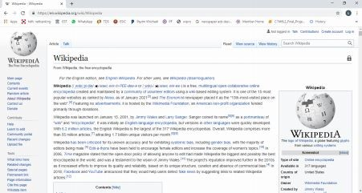

Create your account

Step2: Fill all the information carefully and after that click on the Create your account button to create account.

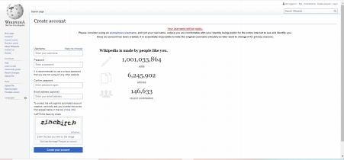

Enter text which you see in upper box

1. Creating your page on Wikipedia

Step1: click on the view source button then you will reach on this page then click on submit an edit request button.

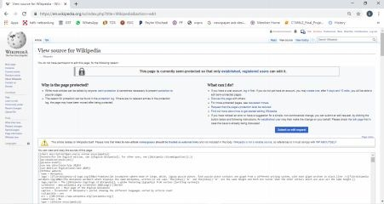

Request to edit the page

Name: - meet mendapara

Roll No:144

Class: FYBSCIT

Step2: Click on New section to create your page.

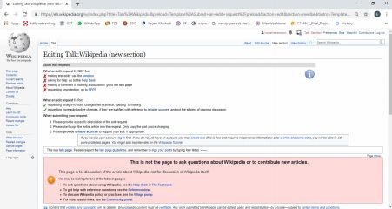 d) Editing your page on Wikipedia

Step1: Click on Create source button and after that click on User page then you will reach on ​ your page. Here you can Edit your page.​

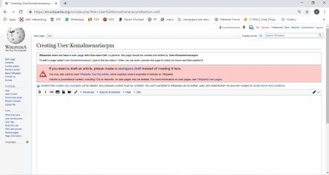

Step2: Here you can fill necessary information and at the end click on Publish changes button to Publish your page information.

Edit your page here

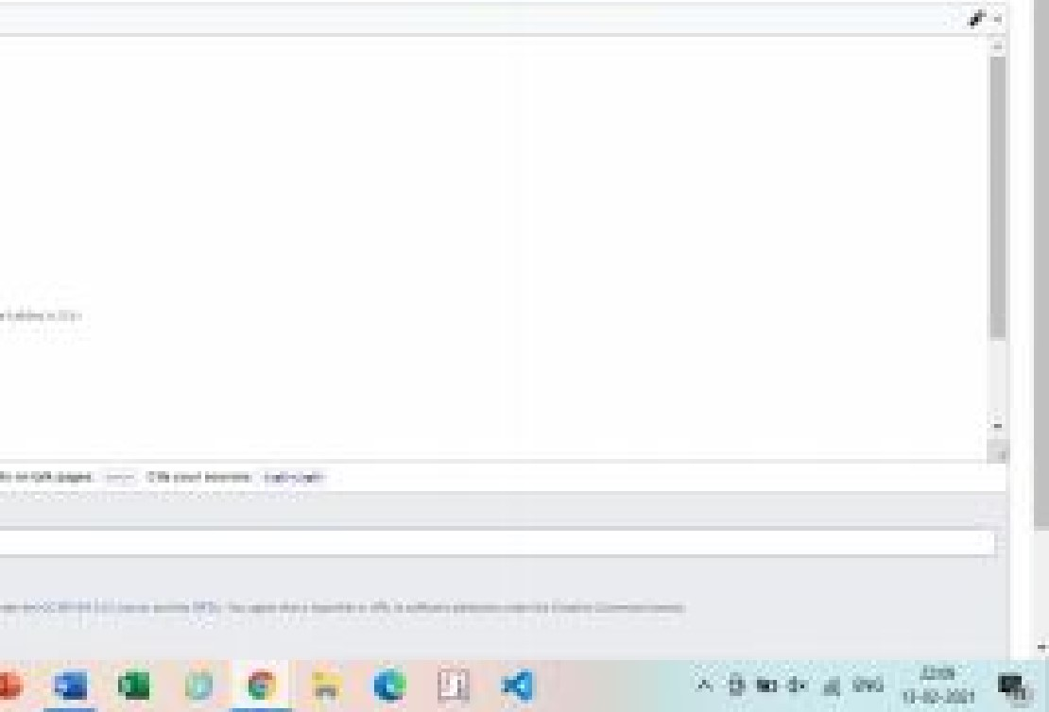Publish your changes

Step3: Click on the read button and you will reach on your edited page.

